**Terraform Task -6**

1. **Watch the Terraform-06 video.**
2. **Execute the script shown in the video.**
3. **Provision EC2, S3, and VPC using Terraform modules.**
4. **Provision EC2 for 3 different environments (Dev, Staging, and Prod) using Terraform workspaces.**

**1.Watch the Terraform-06 video.**

**Completed**

**Terraform Modules:**

**Modules is a collection of configuration files in a directory.**

**Created directories**

**aws_instance**

**resource "aws_instance" "webserver"**

**ami = var.ami**

**instance_type = "t3.micro"**

**}**

**Development**

**module "dev-webserver" {**

**source = "../aws_instance"**

**ami = "ami-02f3f602d23f1659d"**

**}**

**Variables:**

**Variables = “ami” {**

**}**

1. **Provision EC2 for 3 different environments (Dev, Staging, and Prod) using Terraform workspaces.**

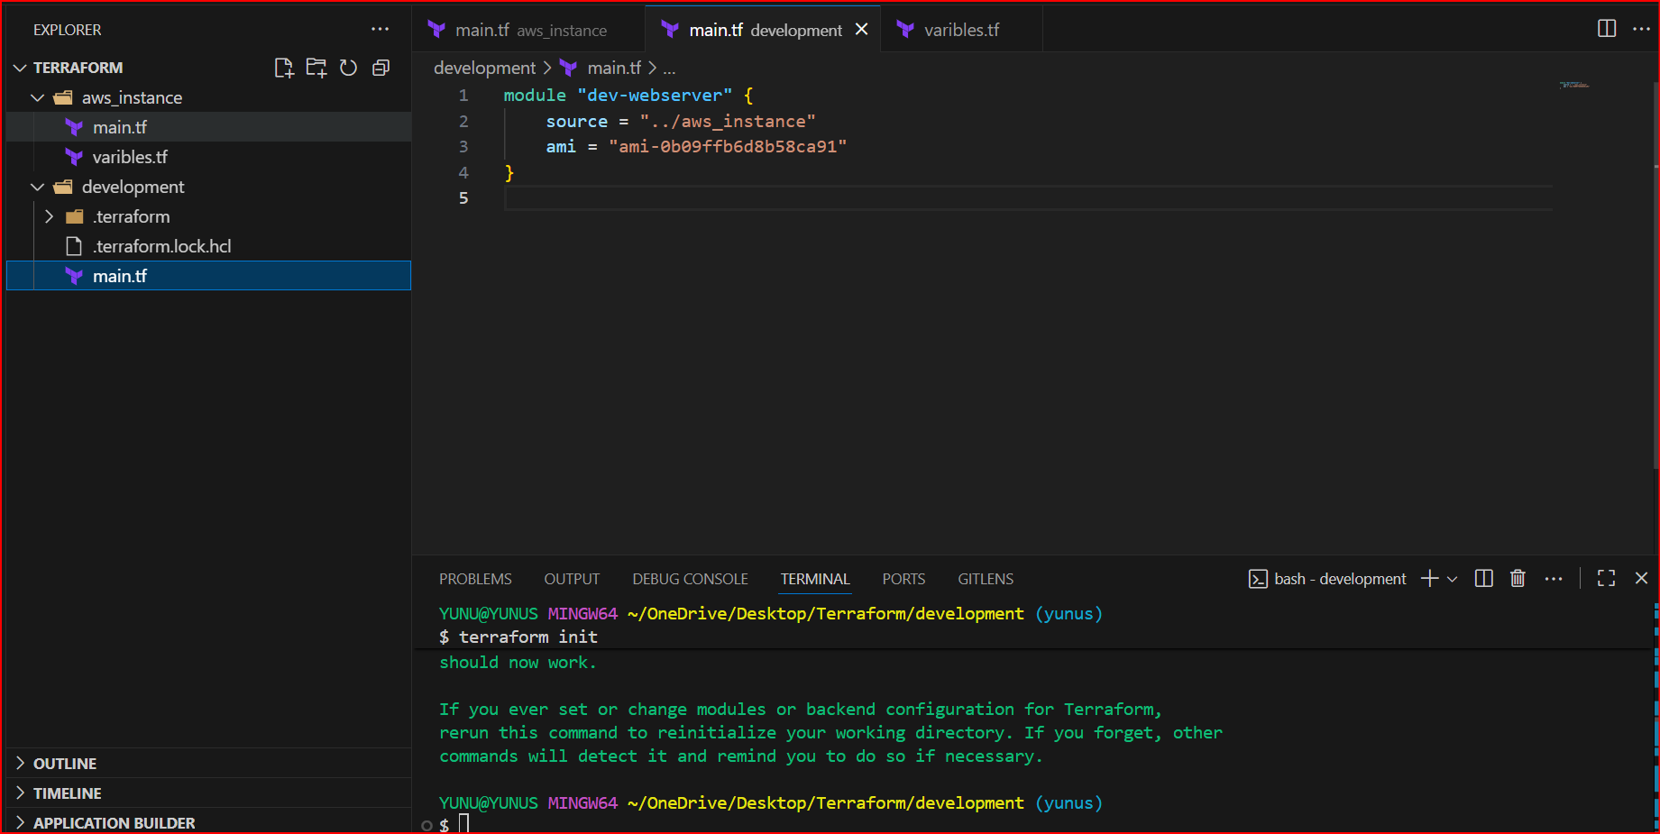

**Terraform init should be do in development**

**Terraform apply**

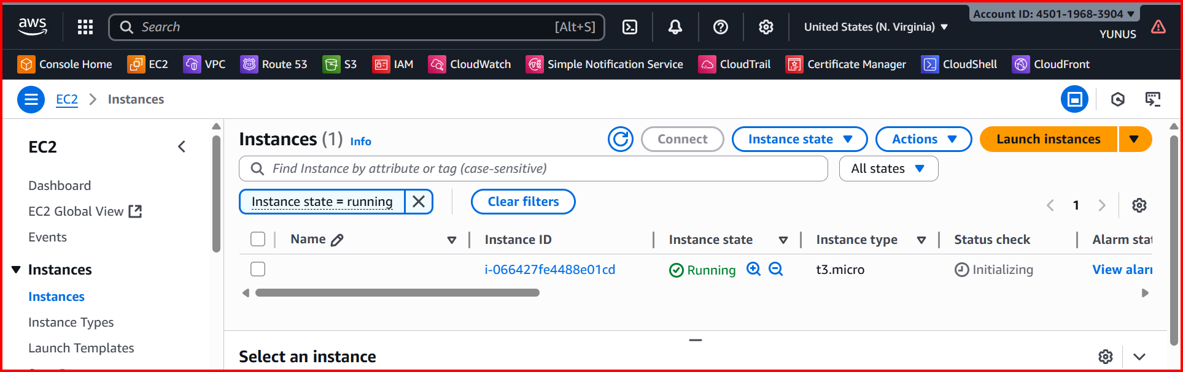

**Staging:**

**Create a directory and write the**

**module "Prod-webserver" {**

**source = "../aws_instance"**

**ami = "ami-02f3f602d23f1659d"**

**}**

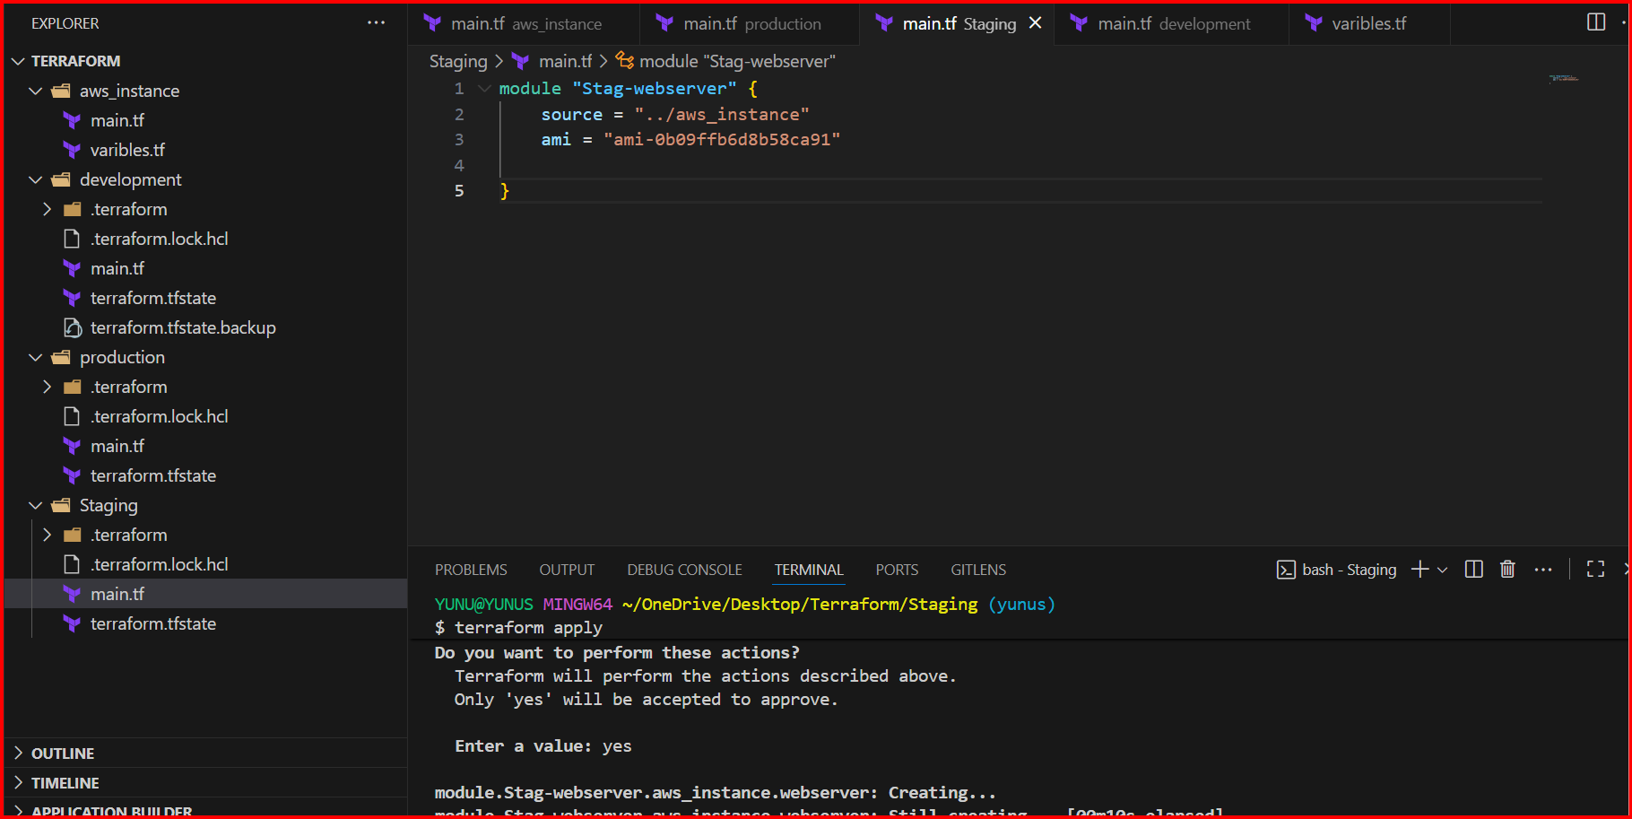

**Production:**

**module "Prodution-webserver" {**

**source = "../aws_instance"**

**ami = "ami-02f3f602d23f1659d"**

**}**

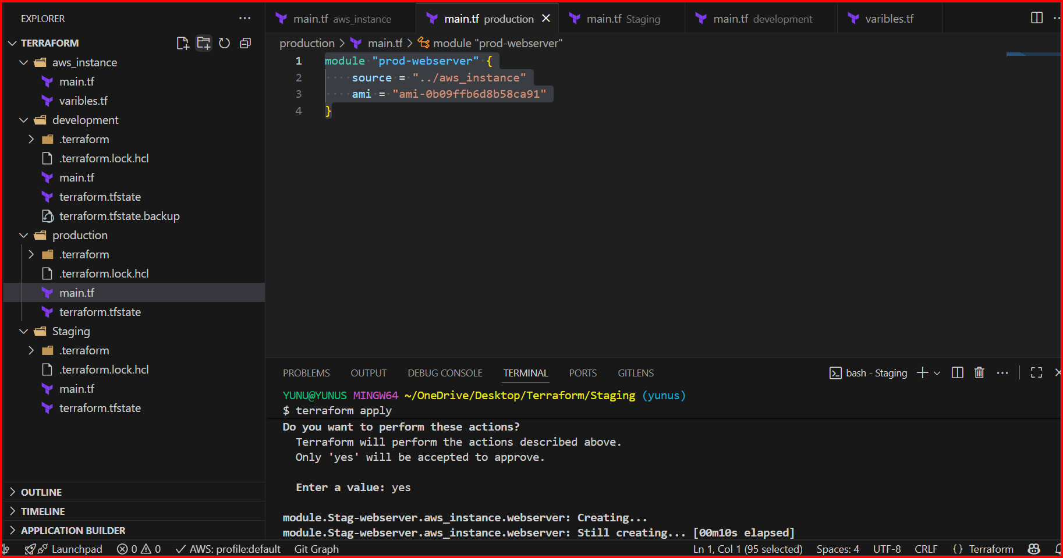

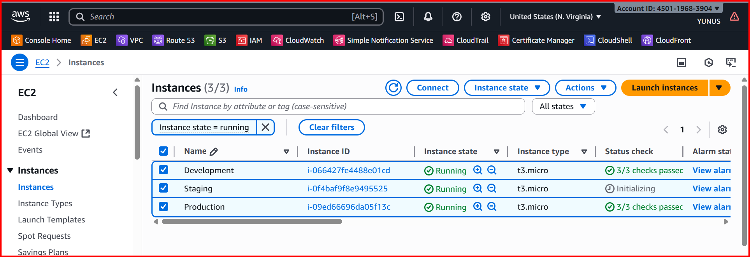

**Terraform workspaces:**

**Workspace can be used if we have multiple project/environments using the same configuration.**

**terraform workspace new projectA --> to create a workspace names projectA**

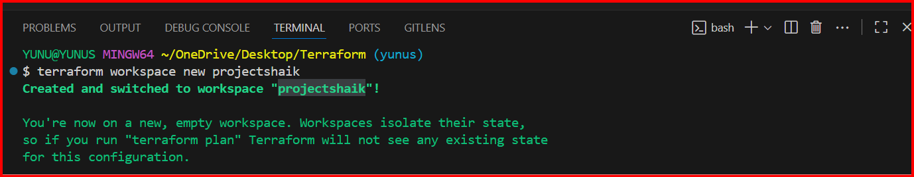

**If you want to check which project you are in**

**Terraform workspace list**

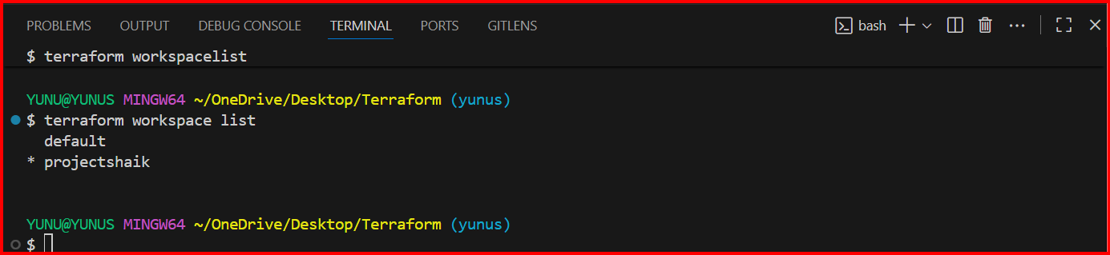

**terraform workspace select projectA --> to swtich to specific workspace**

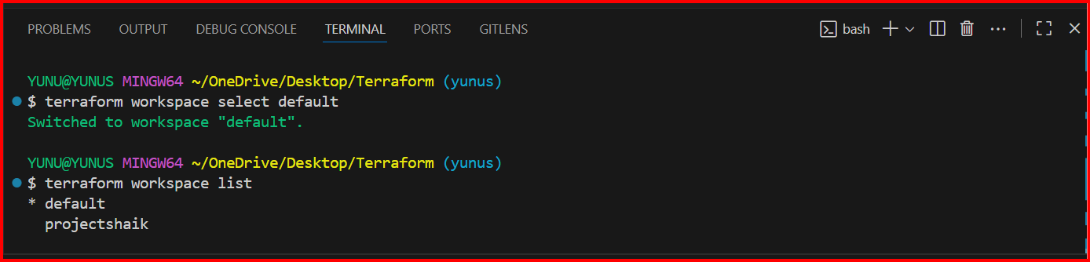

**3.Provision EC2, S3, and VPC using Terraform modules.**

**Terraforminfra/**

**├── aws_instance/**

**│ ├── main.tf**

**│ └── variables.tf**

**├── aws_s3/**

**│ ├── main.tf**

**│ └── variables.tf**

**├── vpc/**

**│ ├── main.tf**

**│ └── variables.tf**

**└── module/**

**└── main.tf <-- this is the root file where you call the 3 modules**

**EC2 Module (aws_instance/)**

**main.tf**

**resource "aws_instance" "webserver" {**

**ami = var.ami**

**instance_type = "t2.micro"**

**}**

**variables.tf**

**variable "ami" {**

**description = "AMI ID to use for the EC2 instance"**

**type = string**

**}**

**S3 Module (aws_s3/)**

**main.tf**

**resource "aws_s3_bucket" "s3_bucket" {**

**bucket = var.bucket**

**}**

**variables.tf**

**variable "bucket" {**

**description = "Unique S3 bucket name"**

**type = string**

**}**

**VPC Module (vpc/)**

**main.tf**

**resource "aws_vpc" "this" {**

**cidr_block = var.vpc_cidr**

**tags = {**

**Name = "myvpc"**

**}**

**}**

**resource "aws_subnet" "this" {**

**vpc_id = aws_vpc.this.id**

**cidr_block = "10.0.1.0/24"**

**availability_zone = "us-east-1a"**

**}**

**variables.tf**

**variable "vpc_cidr" {**

**description = "CIDR block for the VPC"**

**type = string**

**default = "10.0.0.0/16"**

**}**

**3. Root Module (Calling All Modules)**

**Inside module/main.tf you are calling your child modules:**

**module "module-webserver" {**

**source = "../aws_instance"**

**ami = "ami-0d85d4f07a62e2969"**

**}**

**module "vpc" {**

**source = "../vpc"**

**vpc_cidr = "10.0.0.0/16"**

**}**

**module "s3" {**

**source = "../aws_s3"**

**bucket = "s3bucket69875"**

**}**

